LAB 05: Voltage Multipliers I

**Name : Date :**

**Reg-No :**

## OBJECTIVES:

## To study the application of diode as a half wave voltage doubler and a full wave voltage doubler

## SUGGESTED READING:

* Class Lectures
* [Chapter 3: “Diode Applications”, *introductory Electronic Devices and Circuits by Paynter.*](http://arduino.cc/en/Guide/HomePage)
* [Chapter 3: “The Diode as a circuit element”, *Electronic Devices and Circuits by Theodore F. Bogart.*](http://arduino.cc/en/Guide/HomePage)
* Datasheet : 1N4007 rectifier diode
* https://www.electronics-tutorials.ws/blog/voltage-multiplier-circuit.html

Please read through all the suggested reading before you come to lab.

## EQUIPMENT AND COMPONENTS:

* Basic Circuits Training Board
* 1N4007 Rectifier Diode
* Jumper Wires
* Palm Scope / DMM
* Resistors
* Electrolyte Capacitors
* Voltage Transformer

---------------------------------------------------------------------------------------------------------------------

## Voltage Multiplier:

The Voltage Multiplier is a type of diode rectifier circuit which can produce an output voltage many times greater than of the applied input voltage. Voltage multipliers are similar in many ways to rectifiers in that they convert AC-to-DC voltages for use in many electrical and electronic circuit applications such as in microwave ovens, strong electric field coils for cathode-ray tubes, electrostatic and high voltage test equipment, etc., where it is necessary to have a very high DC voltage generated from a relatively low AC supply.

The voltage multiplier is made up of capacitors and diodes that are connected in different configurations. Voltage multiplier has different stages. Each stage is made up of one diode and one capacitor. These arrangements of diodes and capacitors make it possible to produce rectified and filtered output voltage whose amplitude (peak value) is larger than the input AC voltage.

Voltage doublers are classified into following types:

* Half wave voltage doubler
* Full wave voltage doubler

## Half wave voltage doubler:

As its name suggests, a half-wave voltage doubler is a voltage multiplier circuit whose output voltage amplitude is twice that of the input voltage amplitude. A half-wave voltage doubler drives the voltage to the output during either positive or negative half cycle. The half-wave voltage doubler circuit consists of two diodes, two capacitors, and AC input voltage source.

**During positive half cycle:**

The circuit diagram of the half-wave voltage doubler is shown in the below figure. During the positive half cycle, diode D1 is forward biased. So it allows electric current through it. This current will flow to the capacitor C1 and charges it to the peak value of input voltage i.e. Vm.

However, current does not flow to the capacitor C2 because the diode D2 is reverse biased. So the diode D2 blocks the electric current flowing towards the capacitor C2. Therefore, during the positive half cycle, capacitor C1 is charged whereas capacitor C2 is uncharged.

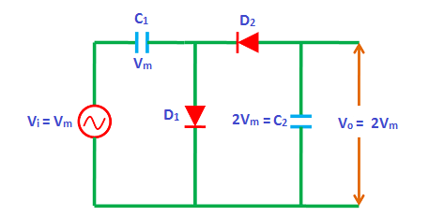

Fig: Half wave voltage doubler

**During negative half cycle:**

During the negative half cycle, diode D1 is reverse biased. So, the diode D1 will not allow electric current through it. On the other hand, the diode D2 is forward biased during the negative half cycle. The diode D2 allows electric current through it. This current will flow to the capacitor C2 and charges it. The capacitor C2 charges to a value 2Vm because the input voltage Vm and capacitor C1 voltage Vm is added to the capacitor C2. Hence, during the negative half cycle, the capacitor C2 is charged by both input supply voltage Vm and capacitor C1 voltage Vm. Therefore, the capacitor C2 is charged to 2Vm.

## Full wave voltage doubler:

The full-wave voltage doubler consists of two diodes, two capacitors and an input AC voltage source.

**During positive half cycle:**

During the positive half cycle of the input AC signal, diode D1 is forward biased. So the diode D1 allows electric current through it. This current will flows to the capacitor C1 and charges it to the peak value of input voltage i.e. Vm.

On the other hand, diode D2 is reverse biased during the positive half cycle. So the diode D2 does not allow electric current through it. Therefore, the capacitor C2 is uncharged.

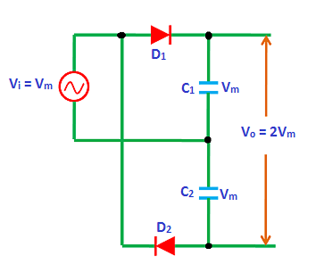

Fig: Full wave voltage doubler

**During negative half cycle:**

During the negative half cycle of the input AC signal, the diode D2 is forward biased. So, the diode D2 allows electric current through it. This current will flow to the capacitor C2 and charges it to the peak value of the input voltage i.e. Vm. On the other hand, diode D1 is reverse biased during the negative half cycle.

Thus, the capacitor C1 and capacitor C2 are charged during alternate half cycles. The circuit is called full-wave voltage doubler because one of the output capacitors is being charged during each half cycle of the input voltage.

## Observations:

**Input voltage =

$C_{1}$ __________**

**=

$C_{2}$ __________**

**= __________**

**Half wave voltage doubler:**

|  |  |  |  |
| --- | --- | --- | --- |
| **Frequency** | $$V_{c1}$$ | $$V_{c2}$$ | **Output voltage** |
|  |  |  |  |
|  |  |  |  |
|  |  |  |  |
|  |  |  |  |
|  |  |  |  |

**Full wave voltage doubler:**

|  |  |  |  |
| --- | --- | --- | --- |
| **Frequency** | $$V_{c1}$$ | $$V_{c2}$$ | **Output voltage** |
|  |  |  |  |
|  |  |  |  |
|  |  |  |  |
|  |  |  |  |
|  |  |  |  |

# REVIEW QUESTIONS:

Q: Draw the half wave voltage doubler circuit if diode D1 conduct during the negative half cycle and D2 conduct during the positive half cycle of the input signal.

Ans:

Q: What is the difference between the output waveform of the voltage doubler and capacitive full wave rectifier?

Q: What will be the effect on the shape of the output voltage of the voltage doubler circuit when the frequency of the input signal is significantly reduced?

Q: What are the advantages of using the voltage doubler?

Q: Why the output voltages are almost same even when the frequency of the input signal was varied during the experiment? Give a logical explanation to it.